Q1. Write a java program to calculate factorial of given number using recursion.

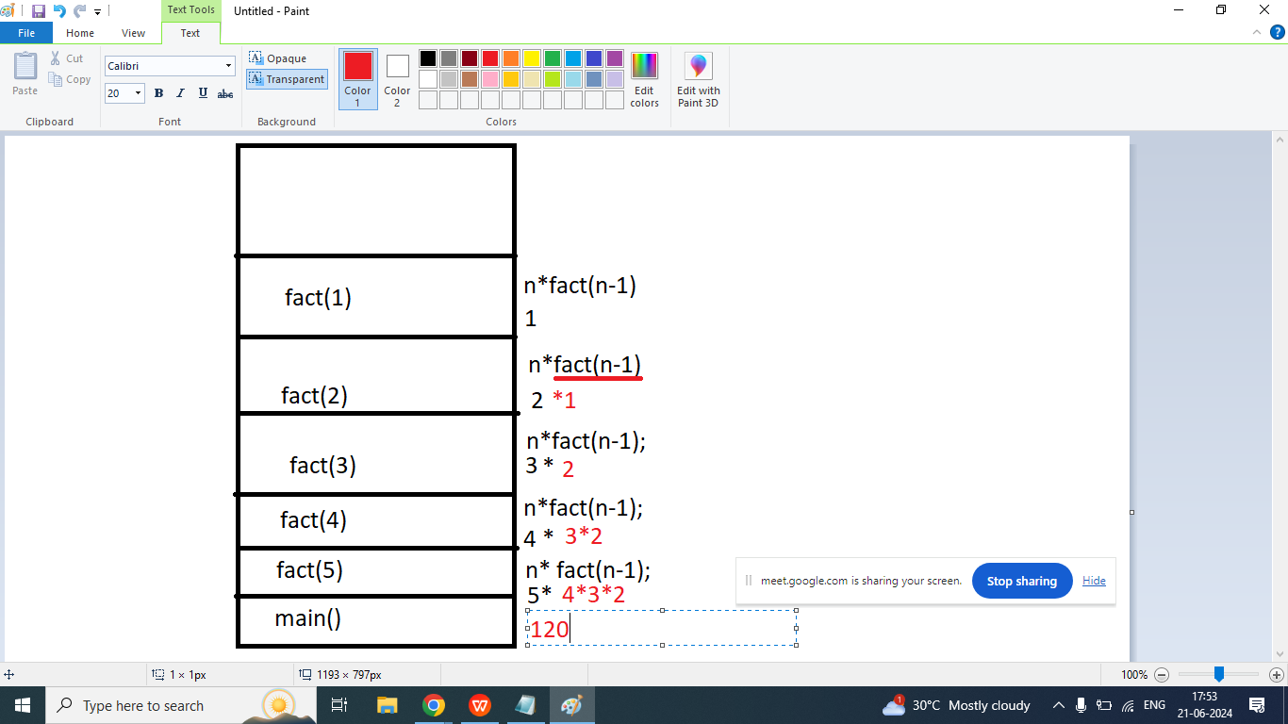

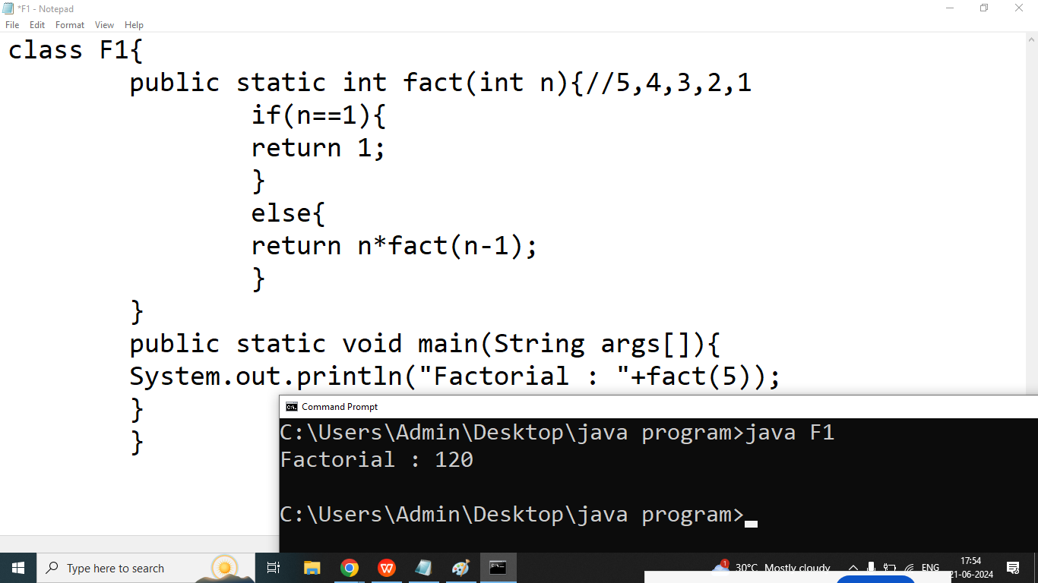

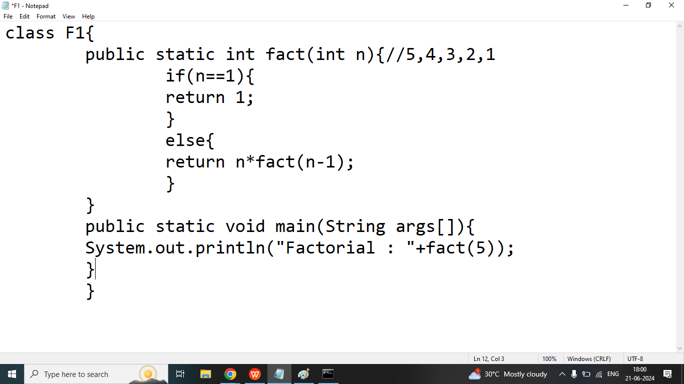

Q2. Write a java program to print nth Fibonacci Number.

Enter Any Number : 3

class F1{

public static void fibo(int n){//5

int a=0,b=1;

System.out.print("\t"+a+"\t"+b);//0 1

for(int i=2;i<=n;i++){

int c=a+b;

System.out.print("\t"+c);//3

a=b;

b=c;

}

}

public static void main(String args[]){

fibo(8);

}

}